**IoT-Based Dynamic Irrigation Scheduling System for Monitoring Irrigated Crops**

Avinash Amudala, Meghana Chagarlamudi, Sahithi Polavarapu, Swetha Sajjala, Ramesh S R

Department of Electronics and Communication Engineering

Amrita School of Engineering, Coimbatore

Amrita Vishwa Vidyapeetham, India

[avinashamudala@gmail.com](mailto:avinashamudala@gmail.com), [meghanach12@gmail.com](mailto:meghanach12@gmail.com), [p.sahithi2000@gmail.com](mailto:p.sahithi2000@gmail.com), [swethasajjala1357@gmail.com](mailto:swethasajjala1357@gmail.com), [sr_ramesh@cb.amrita.edu](mailto:sr_ramesh@cb.amrita.edu)

***Abstract*—Many cropping systems are concerned about effectively managing water. Water management of irrigated crops can be enhanced with the Internet of Things (IoT) and Wireless Sensor Networks. A growing industry of Internet-of-Things (IoT) applications has emerged in countless industrial areas, such as agriculture, healthcare, and logistics. In the advanced industry, the Internet of Things is the key to maximizing productivity and enabling automation. A Dynamic Irrigation Scheduling System for Irrigated Crop Fields Based on the Internet of Things (IoT) is described in this article.Using IoT, the system offers real-time, automatic, dynamic irrigation treatments for different phases of the crop's growth cycle, and manual irrigation treatment for specific locations. Sensors can be designed as budget-friendly devices to detect water levels in a farm, i.e. water level sensors. An irrigation design which is convenient for farmers, which is both automatic and manual is presented. The application has a user-friendly interface that provides farmers with access to farm information via various modes, such as visuals, cell phones, and a web portal. There are notable results relating to water usage prediction, and failure rate of dynamic irrigation in a variety of climatic conditions. Compared with the traditional method of manual irrigation, it helps increase crop productivity. This paper examines IoT trends in agricultural applications today.**

***Keywords—Internet of Things (IoT), Water-level sensor, Smart farming, Dynamic irrigation, Water precision management, Smart irrigation, Wireless Sensor Networks,***

# **Introduction**

Smart farming is an arising concept that alludes to overseeing ranches using advancements like IoT, robots, drones, and artificial intelligence to improve the quality and quantity of products while streamlining human work. IoT has improved nearly every industry imaginable, its impact on agriculture has been tremendous. IoT isn't just providing a solution to often time-consuming and tedious tasks. It's changing the way one thinks about agriculture. The driving force of smart farming is the Internet of Things - connecting sensors and machines on farms to make them more data-driven and automated.

Precision agriculture depends heavily on the management of irrigation water for its crops making water management a key factor [1]-[2]. Crop yield is reduced by inadequate irrigation in terms of water management, scheduling, and scheduling.The ability to efficiently utilize water resources is highly dependent on our ability to meet your urgent food demand, given the current trends in world population growth. By optimizing water use and increasing yields and quality of agricultural crops in the most minimal way possible, water management approaches alleviate dependence on direct human intervention. It is done by ensuring that the water monitoring process runs smoothly, by applying the right level of automation, and by giving farmers access to their farms at any time.

In this paper, an automated irrigation system based on wireless technology and microcontrollers is described and also implemented on a small scale in rural areas. Using automatic irrigation design was intended to demonstrate how water consumption can be reduced. With the Internet of Things (IoT), it is pretty much possible to accomplish the goal of precise water management and water saving from anywhere and anytime. Physical objects can be connected to IoT via actuators, sensors, and wireless connectivity modules that share data with other devices, machines, and humans[3]-[7].

# **Literature survey**

This section highlights research about manual and automated water irrigation with sophisticated technologies like WSNs and IoTs for water precision and conservation agriculture.

## Wireless Sensor Network farming

Research has been conducted in many fields of agriculture [8] based on the improvement of WSNs to enhance the precision and accuracy of farming operations in real-time. In an irrigation system designed for malting barley cultivation at large scale, irrigation optimizer software and an infield wireless sensor network (WSN) controlled an irrigation machine with programmable sprinkler nozzles were used to optimize irrigation. When irrigation is done without analyzing the soil properties, the water is applied unevenly to the soil, resulting in lower yields. A modern irrigation management system will resolve this problem. *Y Kim* proposed that wireless sensor networks and embedded Linux boards are used in this web-based irrigation system. There are two nodes in the proposed system, the end device node and the coordinated node[9]. Through the coordinator, the system will communicate with distributed End device nodes using ZigBee wireless technology. This will enable the system to continuously collect soil temperature and soil moisture data and store this information in a database.Using the Raspberry Pi board and MySQL database, a database is created [9]. Using the received data, the Coordinate node determines how much water is needed for the soil.

In order to control a variable rate irrigation system in real time, J. Gutiérrez designed, constructed, and tested a wireless sensor network (WSN), a remote sprinkler control, and a user-friendly software component[10]. Wireless sensor networks reduce installation and maintenance costs by eliminating the need to hardwire sensor stations.

Various uses of Wireless Sensor Networks in agriculture are described in [11]. The authors in [11], on the other hand, the issue of theft in agricultural fields has been ignored for years which resulted in unauthorized invaders. It regards the entry of an intruder to be a critical issue and has created a prototype intrusion detection system.

WSNs are widely used to achieve accurate results in irrigation systems. A design based on WSN containing a base station and WSN module is connected to a web portal to update the data in the computer. Telos B motes are used to collect the data from the nodes deployed in the field and connect to the computer.

## Internet of Things farming

IoT enables sensors on a field to gather and evaluate a variety of data remotely and send it to the farmer in real time. Imteaj *et al.* [12] proposed an automatic watering system, by using Arduino, Raspberry pi 3 microcontrollers. A WIFI module with IP connectivity handles communication between the sensor node and the receiver node. A SMS alert is sent to the farmer if there is a water shortage when communication between central units and farmers is via GSM. Using daylight sensors, soil moisture sensors, and water level sensors, the proposed irrigation system utilized data from sensors. However, in reality, remote areas may not have access to WIFI services.

An outline of the Cloud of Things' water irrigation system was proposed by Roopaei *et al*. [13], which would be a hybrid of IoT and CPS. Agriculture relies on water and electricity as its two primary inputs. The CoT, a fusion of the Internet of Things and Cyber-Physical Systems, can also improve energy efficiencies in pumps, lighting, boosters, and other applications, in addition to enabling remote monitoring, control, and monitoring of equipment.

This paper presents a lab-scale prototype of an Internet of Things (IoT)-based irrigation system, which detects soil moisture, temperature, and raindrops to estimate the amount of irrigation water needed. Data mining techniques such as regression allow for predicting how much water will be needed for the next iteration based on the amount of water flowing and the temperature of the surroundings. Using a wifi module, the sensed parameters are fed to a mobile application via the cloud aiding the user to access the data. By using the API Key, data is transferred from the microcontroller to the cloud and from there, the mobile app.

# **SYSTEM ARCHITECTURE**

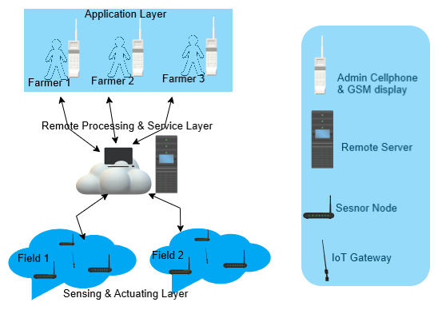

Fig. 1. Proposed System Architecture

In this section, the architecture of the proposed system is presented as mentioned in fig.1. The proposed system follows the conceptual architecture of Wireless Sensor Networks towards the IoT.

## Sensing and Actuator layer

In this layer, Sensor networks are installed in the field to sense environmental conditions and transmit data to gateway nodes through GSM. The data is transmitted by the gateway node to the remote server via GPRS packets. GPRS provides the IoT architecture's core communication, allowing the interaction and integration of physical and virtual items [14]. The sensor node compares data from sensors with thresholds stored in an Arduino. If any distortion from the preset values, the relay board activates the motor.

## Remote Processing and Service layer

The data is processed in this layer from sensors, and the desired operation is performed without human need. The remote processing layer enables the controller to control the field operations remotely. When irrigation is needed, this layer will be executed without the physical presence of the farmer.

## Application layer

A farmer can easily view current operations and field information through this layer. Farmers are equipped with GSM capabilities, so they can transmit data to a mobile phone, and an LCD display with GPRS capability and LED array indication in their house allows them to analyze field data easily. Farmers can also access their field information at any time via the Web server over the Internet. If an intruder enters the field, the farmer receives an alarm message, by using PIR sensors in the node[15].

# **DESIGN OF THE SYSTEM**

This section explains our proposed design for the system. A detailed overview of the different components such as an IoT gateway, a remote server and a sensor node is described in this section.

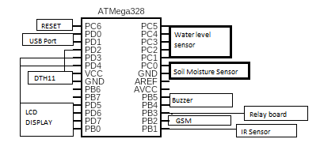Fig. 2. Pin diagram of ATMega328

## Design of Sensor node

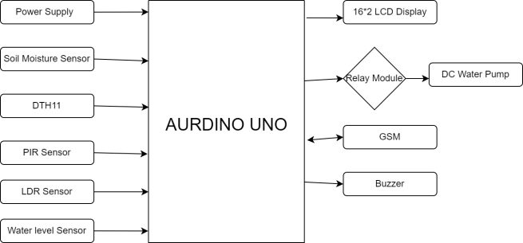

Fig. 3. Flowchart for system design

As demonstrated, a dependable, low-cost energy efficient wireless sensor node is developed. The diagram of the developed sensor node shows the various components that are connected to its processor. The Soil moisture sensor is used to measure the amount of moisture in the soil in the sensor node design.In the field, the DTH11 sensor is used to estimate humidity and temperature. An PIR sensor is used for detecting the intruder that enters the field. An LDR sensor is also used to measure the light intensity. All these sensors are powered by a power supply of 12V. Any information in the sensor node is shown in the 16×2 LCD display attached to the node. Pin diagram of the 16×2 LCD is shown in fig.7. The relay module which is connected to the controller is fed to the input of the DC pump. The relay module acts as an actuator and operates the in and off of the motor based on the sensed input from the controller. Here, two types of boards are used to integrate the microcontrollers to process the system. Arduino(Developed) and Self Developed boards are used for sensor nodes. In Arduino(Developed), ATMega328P microcontroller is used for high performance and low power consumption, which helps for long time usage. Buck converter: In fig.4. It is a 12V to 5V DC-DC step-down converter. Here, a simple circuit for the step down converter, an LM-2596S-3.3 voltage regulator IC and Schottky diode are used in it.

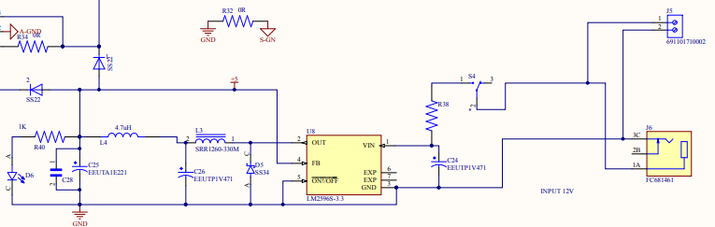

Fig. 4. DC-DC step down converter circuit

1. Power management circuit: In the power section fig.5 power management circuit provides three different power channels for the microcontroller, sensor/actuator and GSM. A low-dropout (LDO) linear regulator with a high power supply rejection ratio, the AP7343 LDO, is used in our system. 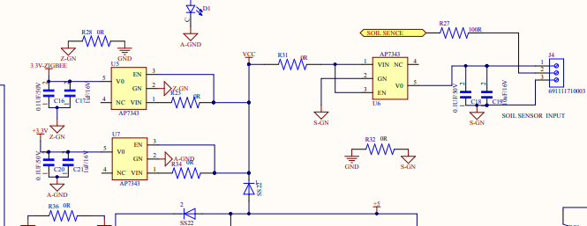

Fig. 5. Power Management circuit

1. Charging circuit: In the charging circuit, the TP4056 linear charger DW01A for battery protection and integrated circuit (IC) is used.

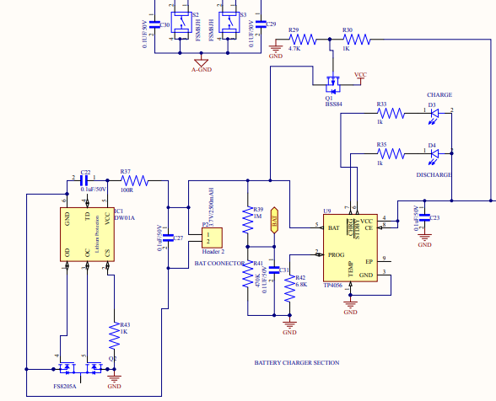Fig. 6. Charging circuit

1. Integration of Sensors and IoT Gateway

In the proposed system, 4 types of sensors are used, soil moisture, DTH11, LDR, and PIR sensor. The soil moisture sensor is interlinked with the relay board through the developed Arduino board. A relay board is connected with the water motor, if water quantity in the soil falls less than the preset value then the sensor sends the information to the relay board, GSM, and LCD display. Relay board acts as a switch here, if the actual value falls below the preset value then the switch will on other it is in off state. If soil is dry, farmers will receive an alert message that “Soil is dry so turn the motor ON” to the mobile phone, LCD display, as well as the data about motor ON/OFF, is uploaded to the server through IoT gateway(GSM). Finally, the Intruder sensor[16], if an object or intruder is detected then sends an alert message to the farmer through GPRS. Simultaneously, all the information is shown below.

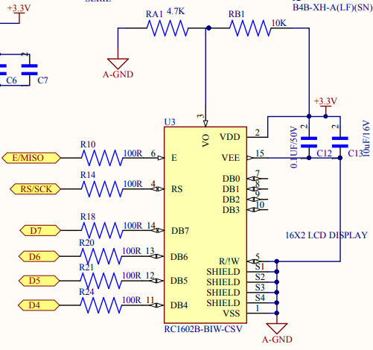

Fig.7. Pin diagram of 16×2 LCD display

1. *Implementation of System server*

In our design, free web services are used which are thingspeak open-source software. By using the API key, it is connected to our system. Need to insert API key and server link in the Arduino code, then the server is connected to the system. For every 30 seconds, data will be automatically uploaded by using GPRS. In Fig. 8 the complete flowchart to build in a traditional way with an IoT based smart irrigation system.

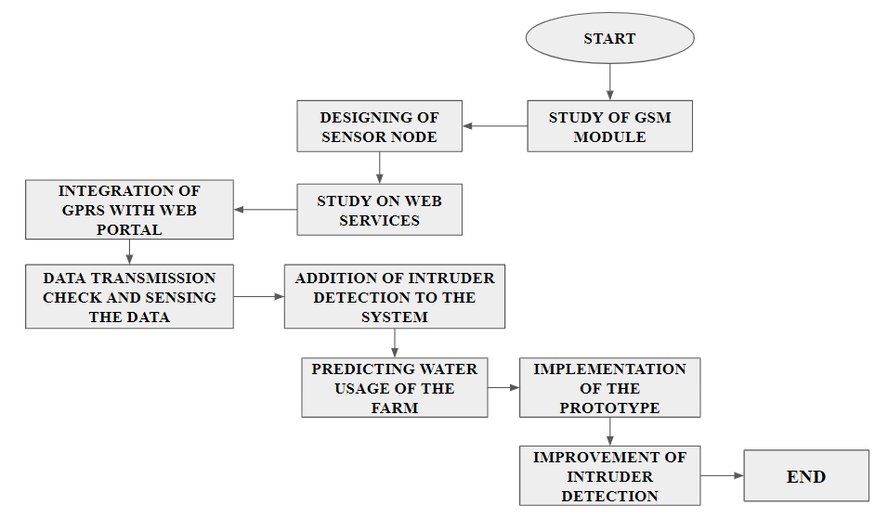

Fig. 8. Flowchart of the system

# **results and discussion**

In fig.9&10 graphs are from the sensor DTH11, which monitors the temperature and humidity of the field. After monitoring one month of this data, by using this one can predict the water usage of that particular crop. This sensor and GPRS are connected to the Arduino so that this information is displayed on the LCD display and also on the web page. To create a web page thingspeak open source software is used to display the data. The web page and server are already mentioned in the Design section IV.

The Relay board is connected to the soil moisture sensor, it acts as a switch to control the soil moisture sensor. Based on this motor will work. In fig. 11. Moisture percentage is shown on both the LCD display and web page. To convert soil moisture percentage a formula is used. I.e .AO = ADCValue/1023, Moisture percentage = 100-(AO*100). This formula is already present in the Arduino code, so that percentage will be displayed. And also the system sends alert messages to the farmer regarding whether the soil is wet or dry as shown in fig. 12.

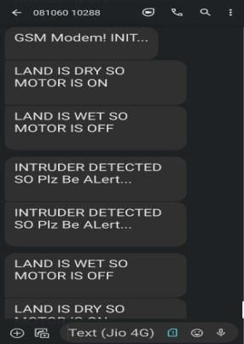

Fig. 12. Administrator mobile phone SMS receiver from system

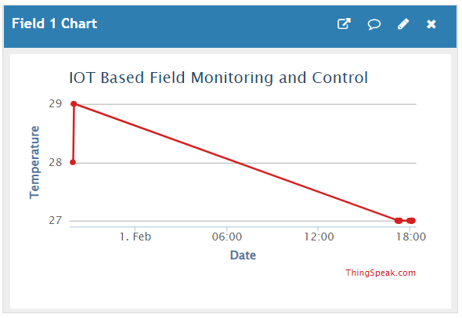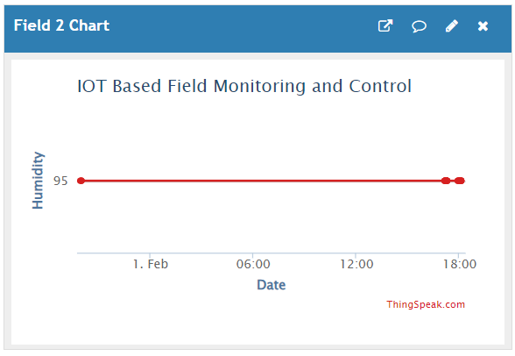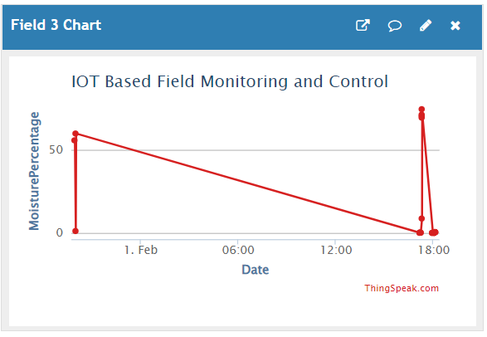

Fig. 9. Data from DTH11 to web server Fig. 10. Data from DTH11 to web server Fig. 11. Data from soil moisture to web server

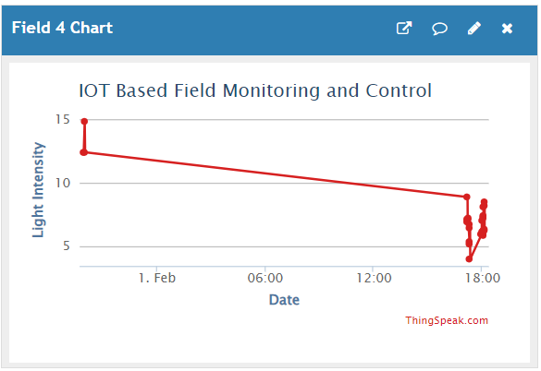

Fig. 13. Data transmitted to the web server from the LDR sensor

In fig.13. It shows the light intensity of the field. By using this one can compare the irrigation process and water requirement with the other crops.

**V.** IMPLEMENTATION

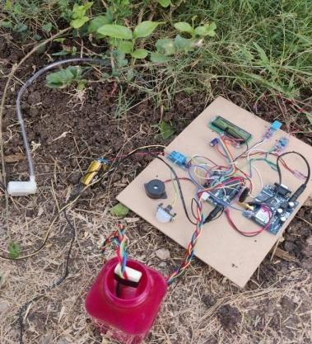

Fig.15. Designed IoT System

Experimented the designed fig.15 IoT system in the household garden in an area of 100 square feet from Feb 15th to March 16th, 2022. As 100 square feet is a comparatively small area, the designed board is placed in the center of the plot. The board has the soil moisture sensor, water level sensor to sense the values and update to the web. All the sensed data is collected on the web and is displayed in the form of a bar graph.

# **conclusion**

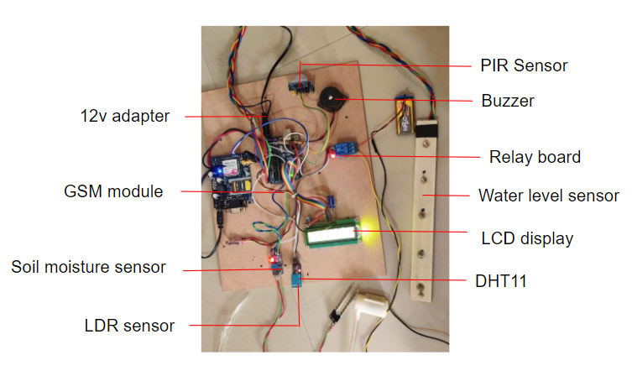Fig. 16. System prototype

The research study that is performed has shown that implementing an automatic water irrigation system can help improve the quality of a plant's production. This method is relatively simple to implement and does not require a lot of money. As sensors improve, this system will become more valuable. A more accurate weather forecast can help improve decision-making regarding water supply and waste reduction. It can also help ensure that the correct amount of fertilizer is delivered to the right place. This system can also help reduce the amount of time that farmers spend on crop maintenance.

##### References

[1] M. Ayaz, M. Ammad-Uddin, Z. Sharif, A. Mansour, and E. M. Aggoune, “Internet-of-Things (IoT)-based smart agriculture: Toward making the fields talk,” IEEE Access, vol. 7, pp. 129551–129583, 2019.

[2] O. Elijah, T. A. Rahman, I. Orikumhi, C. Y. Leow, and M. N. Hindia, “An overview of the Internet of Things (IoT) and data analytics in agriculture: Benefits and challenges,” IEEE Internet Things J., vol. 5, no. 5, pp. 3758–3773, Oct. 2018.

[3] M. Mahbub, “A smart farming concept based on smart embedded electronics, Internet of Things and wireless sensor network,” Internet Things, vol. 9, Mar. 2020, Art. no. 100161.

[4] M. Bhatia and S. K. Sood, “Quantum computing-inspired network optimization for IoT applications,” IEEE Internet Things J., vol. 7, no. 6, pp. 5590–5598, Jun. 2020.

[5] A. P. Kale and S. P. Sonavane, “IoT based smart farming : Feature subset selection for optimized high-dimensional data using improved GA based approach for ELM,” Comput. Electron. Agr., vol. 161, pp. 225–232, Jun. 2019.

[6] R. Marceline, S. R. Akshaya, S. Athul, K. L. Raksana and S. R. Ramesh, "Cloud Storage Optimization for Video Surveillance Applications," *2020 Third International Conference on Smart Systems and Inventive Technology (ICSSIT)*, Tirunelveli, India, 2020, pp. 62-67, doi: 10.1109/ICSSIT48917.2020.9214246.

[7] S. K. Roy, S. Misra, and N. S. Raghuwanshi, “SensPnP: Seamless integration of heterogeneous sensors with IoT devices,” IEEE Trans. Consum. Electron., vol. 65, no. 2, pp. 205–214, May 2019.

[8] Y. Kim, R. G. Evans, and W. M. Iversen, “Remote sensing and control of an irrigation system using a distributed wireless sensor network,” IEEE Trans. Instrum. Meas., vol. 57, no. 7, pp. 1379–1387, Jul. 2008.

[9] S. Prasanna A, B. Madhava Reddy and R. S R, "Design of Combinational Arithmetic Circuits using Quantum Dot Cellular Automata," *2021 5th International Conference on Trends in Electronics and Informatics (ICOEI)*, 2021, pp. 117-122, doi: 10.1109/ICOEI51242.2021.9453069.

[10] J. Gutiérrez, J. F. Villa-Medina, A. Nieto-Garibay, and M. Á. Porta-Gándara, “Automated irrigation system using a wireless sensor network and GPRS module,” IEEE Trans. Instrum. Meas., vol. 63, no. 1, pp. 166–176, Jan. 2014.

[11] P. H. Tarange, R. G. Mevekari, and P. A. Shinde, “Web-based automatic irrigation system using wireless sensor network and embedded Linux board,” in Proc. Int. Conf. Circuit Power Comput. Technol., Nagercoil, India, Mar. 2015, pp. 1–5.

[12] A. Imteaj, T. Rahman, M. K. Hossain, and S. Zaman, “IoT based autonomous percipient irrigation system using Raspberry Pi,” in Proc. 19th Int. Conf. Comput. Inf. Technol., Dhaka, Bangladesh, Dec. 2016, pp. 563–568.

[13] M. Roopaei, P. Rad, and K. K. R. Choo, “Cloud of Things in smart agriculture: Intelligent irrigation monitoring by thermal imaging,” IEEE Cloud Comput., vol. 4, no. 1, pp. 10–15, Jan./Feb. 2017.

[14] M. Karthikeyan, V. Manesh, L. S. Krishna, B. Vijay, R. Vishwabharan and E. Prabhu, "IoT based Accident Detection and Response Time Optimization," *2021 5th International Conference on Computing Methodologies and Communication (ICCMC)*, 2021, pp. 358-363, doi: 10.1109/ICCMC51019.2021.9418272.

[15] S. K. Roy, A. Roy, S. Misra, N. S. Raghuwanshi, and M. S. Obaidat, “AID: A prototype for agricultural intrusion detection using wireless sensor network,” in Proc. IEEE Int. Conf. Commun., London, U.K., June. 2015, pp. 7059–7064.

[16] Kukan S., Gokul S., Vishnu Priyan S.S., Barathi Kanna S., Prabhu E. (2022) COVID-19: Smart Shop Surveillance System. In: Raj J.S., Palanisamy R., Perikos I., Shi Y. (eds) Intelligent Sustainable Systems. Lecture Notes in Networks and Systems, vol 213. Springer, Singapore. <https://doi.org/10.1007/978-981-16-2422-3_55>